 | EUNOIA JUNIOR COLLEGE  JC2 Preliminary Examination 2024  General Certificate of Education Advanced Level  Higher 2
H2 GEOGRAPHY  Paper 2  INSERT |  | 9173/02  16 September 2024  3 Hours
READ THESE INSTRUCTIONS FIRST

The Insert contains all the Resources referred to in the questions.

This document consists of 8 printed pages.
[Turn over
2

Resource 1 for Question 1

Map of Bishan-Ang Mo Kio Park

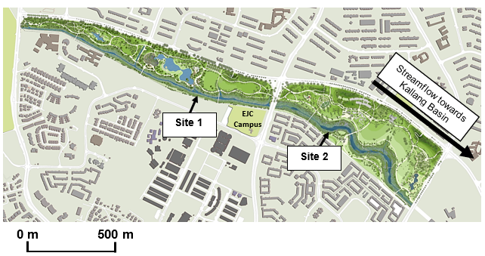

3

Resource 2A for Question 1

Photograph of river at Site 1

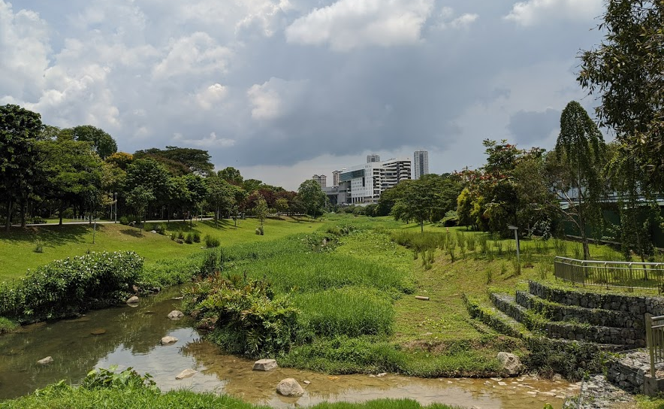
Site 1

Resource 2B for Question 1

Photograph of river at Site 2

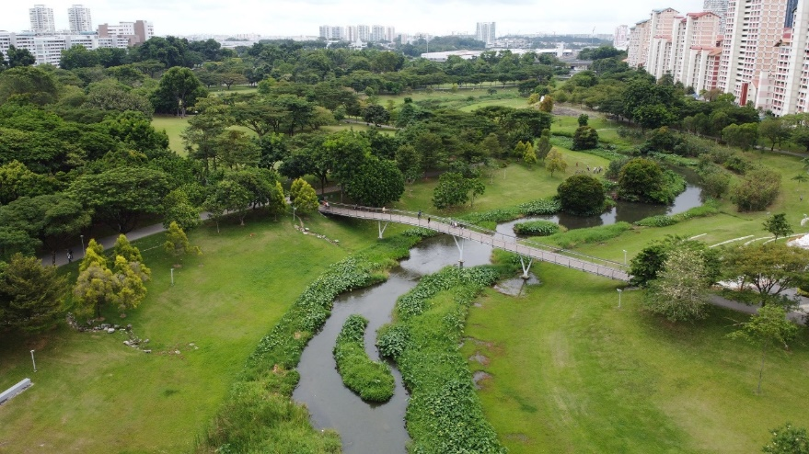
Site 2

[Turn over

4

Resource 3 for Question 1

Data collection sheet

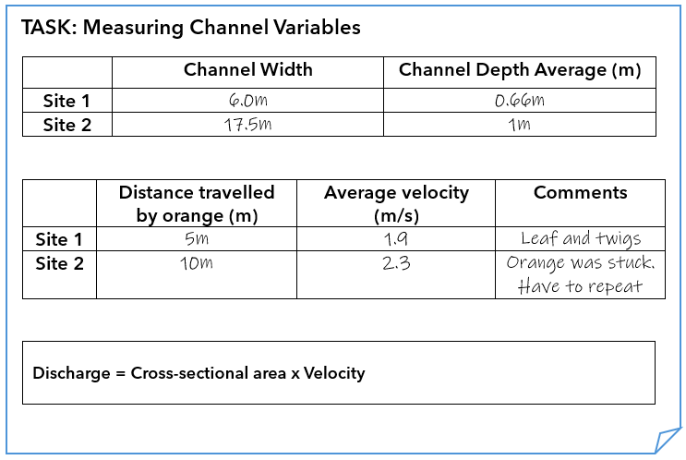

5

Resource 4 for Question 1

Flood risk perception survey

Flood Risk Perception Survey

Gender:

Age:

- How often do you visit Bishan-AMK Park?
  - Daily
  - Weekly
  - Monthly
  - Rarely

- Are you aware of any flood incidents in Bishan-AMK Park in the past?
  - Yes
  - No

- How would you rate the flood risk in Bishan-AMK Park?
  - Very low risk
  - Low risk
  - No risk
  - High risk
  - Very high risk

- Have you seen any flood mitigation measures in place in the park (e.g. drainage systems, retention ponds, adaptive capacity of channels)?
  - Yes
  - No

- How effective do you think these flood mitigation measures are in reducing flood risk?
  - Highly effective
  - Effective
  - Neutral
  - Ineffective
  - Very ineffective

- Do you feel safe when visiting Bishan-AMK Park during the rainy season?
  - Yes
  - No
  - Neutral

[Turn over
6

Resource 5 for Question 2

Changes in carbon emissions by world region from 1990 to 2012

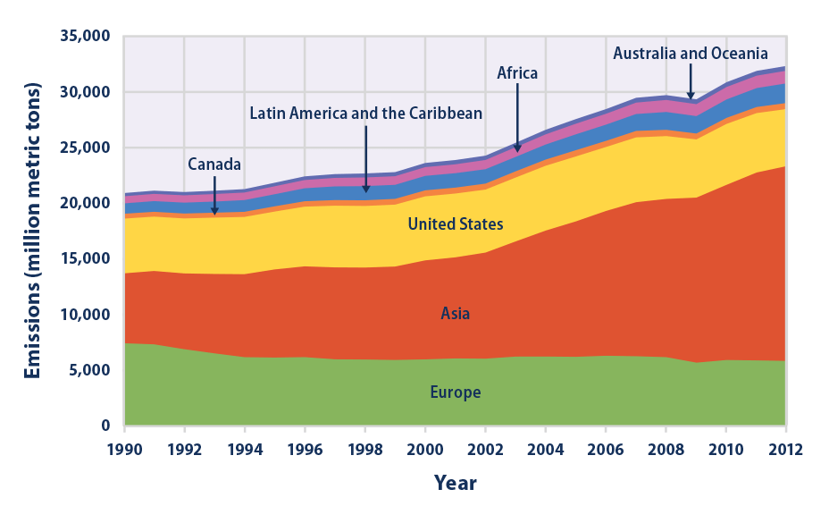

7

Resource 6 for Question 2

Changes in surface temperatures in China from 1951 to 2011

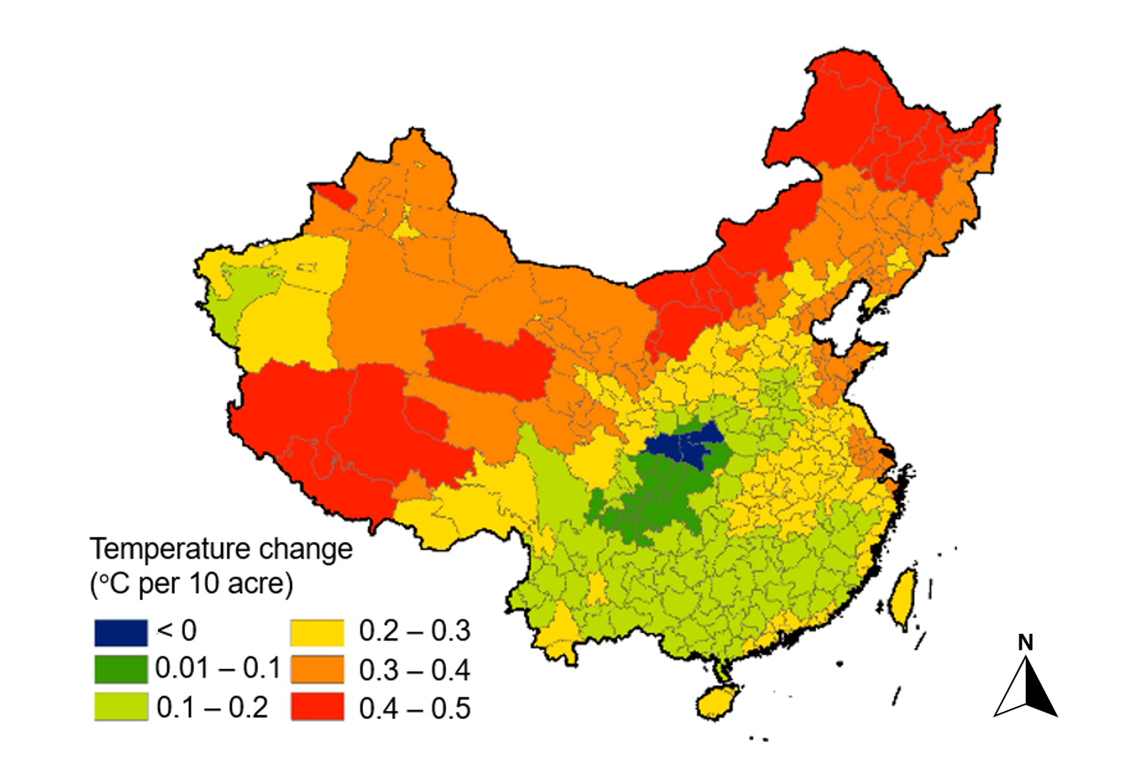

Resource 7 for Question 2

Excerpt on the effects of contemporary climate change in China

…Like the rest of the world, China will increasingly suffer over the next few decades from the effects of climate change, which include sea-level rise, stronger storms, and more intense heat waves. China’s average temperature and sea levels have risen faster than the global average, according to a 2020 report from China’s National Climate Center.

Some of China’s coastal cities, such as Shanghai, could be submerged if the global average temperature continues to rise. An estimated forty-three million people in China live on land that could be underwater by the end of the century if the global average temperature rises by 2°C.

Additionally, experts predict that China will experience more frequent extreme weather events, such as heavy rainfall. As temperatures rise, China’s glaciers will continue to melt at an alarming rate, which will likely lead to more devastating floods. Extreme heat events and droughts will also become more common...

[Turn over

8

Resource 8 for Question 2

Infographic on features in Tianjin Eco-City, China

